Environmental Protection Agency
Incident Command System

Environmental Unit Leader Job Aid
January 2009

Questions or comments about this Job Aid?
Please contact Roberta Runge at runge.roberta@epa.gov

Environmental Protection Agency
Incident Command System
Environmental Unit Leader Job Aid

Overview/Mission
The Environmental Unit of the Planning Section is established to promote the use of sound science and engineering principles to support response decisions regarding protection of public health, welfare, and the environment.

User
The user of this Job Aid will be anyone who is assigned as the Environmental Unit Leader (ENVL) within the Incident Command System (ICS) at an incident. Personnel assigned to this position should have response experience and a strong understanding of how environmental issues can be affected by an incident.

When to Use
This Job Aid should be used as a guide for the ENVL to perform his/her duties whenever an incident has occurred that requires an Environmental Unit within an ICS. This Job Aid is meant to cover the key items that an ENVL will have to address, and not every possible technical need that many be required at a response. In the event of a nationally significant incident where a Headquarters Environmental Unit is activated, this Job Aid will assist the ENVL in interacting with the Headquarters Environmental Unit. Refer to Appendix I for the ENVL and Headquarters Environmental Unit coordination matrix for nationally significant incidents.

Key Responsibilities and Products
It is the responsibility of the Planning Section/Environmental Unit to provide technical information and recommendations to the Operations Section so they can make the best tactical decisions. The responsibility for the development of plans is shared by the Operations Section and Planning Section. Strategic planning is the responsibility of the Planning Section. Tactical planning is controlled by the Operations Section. The Operations Section will draw on the technical expertise in the ENVL to ensure that the technical approach in the specified operational period is effective and acceptable to stakeholders. The ENVL will assist the Operations Section through the development of sampling plans, data processing and interpretation, development of environmental models, and technology evaluation.

The primary responsibilities of the ENVL are:
- Use the appropriate technical approach to make recommendations regarding the protection of public health, welfare, and the environment.
- Coordinate with Headquarters Environmental Unit during a nationally significant incident. See Appendix I.
- Coordinate and support the Scientific Support Coordinator (SSC) when one is assigned to the incident.
- Provide appropriate technical advice and consultation to the Planning Section, Operations Section, and the Incident Commander (IC) in support of the decision making process in the following areas (to accomplish this work a cadre of technical specialists may be needed, refer to Appendix II):
  - Sampling Planning, Analysis, and Environmental Monitoring;
  - Quality Assurance;
  - Data Evaluation, Processing, and Interpretation;
  - Environmental Modeling;
  - Perform Ecological Assessments;
  - Perform Human Health Assessments;
  - Assess Response and Cleanup Technologies
- Direct, organize, and manage the activities undertaken by the Environmental Unit. See Appendix III for a sample organizational chart.
- Communicate effectively with other members of the response and stakeholders.
- Prepare Environmental Data and Information presentations and packages.
  - A key function of the Environmental Unit is to provide environmental data and information for many uses. The format will vary depending on the end user. A large amount of the data and information will be prepared in a format (package) that the Situation Unit Leader (SITL) can combine with other incident information to develop a Common Operational Picture of the incident, maintain Situational Awareness in the field, be able to communicate this both internally and externally, and be used as a basis for making sound operational and tactical decisions.

Sampling Planning, Analysis, and Environmental Monitoring
The ENVL is responsible developing plans to assess special environmental conditions or impacts related to an incident and evaluating strategies to minimize those impacts (see Appendix VI). The ENVL will ensure that incident-specific environmental media monitoring and sampling strategies are developed to systematically collect data to aid in response decision-making.
- In close coordination with the PSC, develop plans to assess and minimize environmental impacts.
- Coordinate special scientific topics with the SSC.
- Assemble appropriate sampling and analysis plans for collecting, transporting, and analyzing samples, as requested by the IC and/or Operations Section, and in close coordination with Operations Section.
- In coordination with the Operations Section, identify needs for special technical equipment and request equipment through the appropriate acquisition and ordering mechanism.
- Provide summary reports as requested by the IC or the PSC.
- Ensure standardized analytical data format, unique location, and sample identifier.
- Establish consistent data nomenclature (e.g., sample names, sample media classes, analyze names, etc.).
- Develop the Quality Assurance Project Plan (QAPP).
- All plans need to be in accordance with US EPA procedures, protocols, and guidance. See Appendix IV.

Quality Assurance
The ENVL will ensure that data quality assurance is fully integrated into the entire response. This function may be delegated to appropriate Environmental Unit staff.
- Establish Data Quality Objectives (DQO) that are appropriate for the end user. Refer to Appendix VIII.
- Ensure standardized analytical data format, unique location and sample identifier.
- Review the QAPP.
- Ensure that appropriate data validation occurs.

Data Evaluation, Processing, and Interpretation
The ENVL must ensure that Environmental Unit personnel evaluate data collected for usability and communicates the information to the rest of the IMT (see Appendix VIII).
- Conduct data evaluation.
- Conduct data interpretation.
- Ensure sampling data, analytical results and data interpretation are available for use in the decision making process.
- Provide summary reports as requested by the IC or the PSC.
- Work with SITL to present data.
- Ensure consistent data nomenclature (e.g., sample names, sample media classes, analyze names, etc.) are used.

Environmental Modeling
The ENVL must ensure that the modelers are using models that are relevant to the specific conditions of the incident. The ENVL must understand and communicate the limitations and assumptions associated with models, and communicate those limitations to the PSC and stakeholders. In concert with the modelers, the ENVL must establish the following:
- Coordinate with Interagency Modeling and Atmospheric Assessment Center (IMACC) for modeling of atmospheric releases of hazardous substances during an INS. See Appendix IX.
- Work with PSC to define modeling objectives.
- Review existing data and identify data gaps. Propose methods for addressing data gaps. Additional data collection methodologies will be discussed with personnel within the Environmental Assessment Branch of the Operations Section.
- Determine if modeling is appropriate and what type of modeling and modeling tools are available and appropriate.
- Select appropriate modeling tool.
- Conduct flow (groundwater, contaminant, and oil trajectory) and fate and transport (including air dispersion) modeling. This may involve coordination of modeling atmospheric releases of hazardous substances during an INS with DHS’ IMACC.
- Provide summary reports as requested by the IC or PSC.
- Work with SITL to present data.

Response and Cleanup Technologies
The ENVL is responsible for assessing the environmental conditions or impacts related to an incident and developing strategies to minimize those impacts.
- Identify sensitive areas and recommend response priorities in close coordination with the PSC.
- Consult with Natural Resource Trustees with regard to natural, cultural, and historical resources protection (e.g., mitigating incident impacts).
- Identify and evaluate the potential use of various response technologies.
- Identify and recommend preliminary benchmarks, criteria, and endpoints for cleanup.
- Consult with state and local authorities, and adhere to federal, state and local regulations. Identify the need for, and obtain necessary and appropriate permits, consultations, and other authorizations including awareness of and adherence to Endangered Species Act (ESA) provisions.
- Develop assessment and clean up plans, as appropriate. Identify the need for and recommend any special advisories or orders.
- In coordination with the Operations Section, identify needs for special technical equipment and request equipment through the appropriate acquisition and ordering mechanism.
- Assemble disposal plans, as requested by the PSC and/or the OPS.
- Provide summary reports as requested by the PSC.
- Monitor the environmental consequences of cleanup actions.

Ecological and Health Assessments
The Environmental Unit will perform short-term and long-term risk assessment, as appropriate, to determine action and cleanup levels.
- Evaluate preliminary benchmarks, and criteria, and perform short-term and long-term risk assessment, as appropriate, to identify action and cleanup levels.
- Evaluate action level for the protection of worker health and Safety (H&S) in coordination with the safety officer.
- Coordinate with Local, State and Federal health and environmental agencies.
- Provide summary reports as requested by the IC or the PSC.

Reach Back Resources
There are multiple special teams and organizations both in and out of EPA that can assist in fulfilling and accomplishing the Environmental Unit mission, and supplying technical experts to the field. Refer to Appendix X for a listing and description of these teams as well as contact information.

Routine Duties
- Conduct Environmental Unit Staff meetings to assign tasks, set priorities, assess personnel needs, identify conflicts, etc.
- Attend Operations briefing.
- Participate in Planning Section meetings.
- Attend Tactics meetings, as appropriate.
- Communicate among stakeholders and response personnel.
- Maintain a list of response related contacts.
- Document appropriate response related activities, communications actions and pertinent communications in Unit Log.
- Maintain daily, weekly, monthly and response Unit/Activity Log.
- Keep PSC apprised of work status.
- Order/Demob Resources as needed.

Materials
Ensure that these materials are available in the Environmental Unit during an incident, if not already provided in a unit- or section-specific support kit. Submit order request for supplies to Supply Unit Leader via the Planning Section Chief (PSC). This is a general list of materials; see Appendix V for a comprehensive list.

- EPA Incident Management Handbook (IMH) (epaosc.net/NIMSIntegrationTeam)
- Computer, appropriate software, and accessories   
- Office Supplies
- Local Charts and Maps
- EPA Templates (e.g., Sampling Plans, QAPP, etc.)
- ICS Forms and Templates (epaosc.net/ICS_FORMS)
- Rapid Assessment Tool (RAT)
- Bound Log Book
- Cell Phones
- ESI
- Digital Camera
- Job Aid
- Job Aid Reference CD

Checklist of Initial ENVL Tasks
Below are potential responsibilities of the ENVL at the beginning of a response.
ACTION | ✓
Receive assignment
Review Unit Leader Responsibilities and IMH
Upon arrival at the incident, check-in at designated check-in locations. Check-in locations may be found at:
- Incident Command Post
- Base
Obtain an initial brief from PSC:
- Size and Complexity of incident;
- Expectations of the IC;
- Incident objectives;
- Agencies/Organizations/stakeholders involved;
- Assignments for the Environmental Unit;
- Incident activities/situation/current status; and
- Special concerns.
Review ICS Form 201-EPA or IAP
Begin/maintain Unit Activity Log (ICS Form 214-EPA)
Establish work location within the ICP:
- Ensure adequate space for possible expansion;
- Locate Unit in the Planning Section adjacent to the Situation Unit; and
- Assess and establish communications’ capabilities (e.g., phone, fax, and modem).
Acquire work materials listed above
Determine staffing requirements for Environmental Unit and the need for technical specialists (Example: Trajectory Analysis Specialist, Shoreline Cleanup Specialist, Resources At Risk Specialist) and establish an internal Environmental Unit organizational chart (see example in Appendix III).
Assess the work to be done, and the resources currently on hand
Submit resource order form/request for personnel and/or equipment required to PSC.
Brief Environmental Unit Staff on responsibilities as noted in IMH.
Complete forms and reports required of the assigned position and send through PSC to Documentation Unit.

Communication
The response may call for additional communications; this matrix provides a list of common contact points. Below is an input/output matrix to assist the ENVL in obtaining information from, and providing information to, other ICS positions.
MEET WITH | WHEN | ENVL OBTAINS | ENVL PROVIDES
Incident Commander | Initial incident  brief | Incident objectives | Requested environmental  information and recommendations
Planning  Section Chief  Objectives (ICS Form 202-EPA) | Check-in brief  Tactics meeting  Planning meeting  Planning Section Meetings | Requests for additional personnel and resources | Environmental information  Recommendations for response options  Current and Future priorities  and actions  Plans, Data, Interpretations, and other products
Operations  Section Chief (OPS) | Tactics meeting  Planning meeting | Incident situation  status during initial  phase and throughout  entire incident and buy-in from OPS on plan development for sampling and response options | Recommendations for response options  Sampling and analysis plans  Interpreted data, modeling results, technical information, etc
Public Information  Officer | Press briefings | NA | Environmental data, information, and interpretations in plain language
Environmental  Unit Personnel | Throughout  incident | Information from  tech specialists  Products | Information, products, plans, data, etc.
Situation Unit | Planning Meeting  As needed | Access to database, GIS products (maps, charts), and situational updates | Environmental data and data interpretation  Information for displays (maps, charts, tides, weather, etc.)
Liaison Officer | As needed | Cooperating agency and other stakeholder participation | NA
Scientific Support Coordinator | As needed | Special Topic Briefings | Incident Environmental Data and Interpretation

References
An Environmental Unit Reference CD is enclosed. A table of contents for this CD can be found in Appendix IV.

APPENDIX I: Environmental Unit and HQ Environmental Unit Matrix for a nationally significant incident

Responsibility | Environmental Unit | Headquarters Environmental Unit
Sampling and Analysis Plan (SAP) | Develop comprehensive SAP designed for specific needs of incident. Shall include, but not be limited to: all aspects of sampling and monitoring processes, decisions on analytes-of-concern, required analytical methodology, choice of analytical laboratory(s), laboratory procurement (e.g. START vs. Regional procurement), and data reporting format | Coordinate review of the SAP among the Headquarters offices (ORD, OGC, others) and outside groups such as the Science Advisory Board. Provide comments to the Field Environmental Unit and concur on final SAP.  Brief Sr. Management on the SAP to ensure that the Plan fulfills the Agency/DHS objectives for sampling.  Work with Office of External Affairs to develop public statements on the SAP and upcoming field activities.
Quality Assurance Project Plan (QAPP) | Develop and revise, as necessary, QAPP for specific needs of incident. Shall include, but not be limited to: decisions on level of data validation required for incident, appropriate parties to perform data validation, use of field Quality Assurance Samples (field blanks, replicates, blind Performance Evaluation Samples, etc.), | Same activities as the SAP.
Review of Laboratory Data | Review data to ensure completeness and usability. Ensure that requirements of SAP and QAPP are met. Coordinate with laboratory or START contractor on laboratory quality issues. Make results available to Sr. Managers for decisions concerning immediate environmental impact issues. | Review data to ensure completeness, accuracy, and usability. Identify issues for clarification or revision for follow up by the Field Environmental Unit.  Ensure that format of data submitted to the HQ Environmental Unit meets the formatting requirements for posting on the Internet.
Data Validation | Ensure laboratory data is validated by processes and frequency outlined in the QAPP. Ensure that data has been validated correctly. Coordinate with laboratory or START contractor concerning issues on quality. Request supplemental data from laboratory to support further data review or validation. Ensure data has been properly qualified in accordance to the data validation report. Ensure qualified data has been reported to the database. | Review data validation reports originating from Regional operations or third party validators. Perform additional data validation, as needed. Request supplemental data from Field Environmental Unit and/or the laboratory to support further data review or validation.
Data Interpretation | Develop a draft report comparing the analytical data to appropriate health based or regulatory screening levels and the draft to HQ Environmental Unit. Describe potential health effects, exceedance of health standards, screening values, EPA risk range, etc. | Coordinates with field Environmental Unit, internal health experts (e.g. ORD), external health experts (e.g. ATSDR), etc to determine health and environmental impacts with respect to laboratory results. Coordinates final release of interpreted data. Develops daily summaries of data posted to the Internet.
Risk Assessment | Coordinates with HQ Environmental Unit to develop a detailed risk assessment of event and area involved. | Coordinates with field Environmental Unit, internal risk assessment experts (e.g., ORD), external risk assessment experts, etc to determine assessment of risk for impacted area. Final release of risk assessment will be made by HQ Environmental Unit.
Risk Communication | Coordinate with HQ Environmental Unit to develop public statements about the analytical data and comparisons to health based screening levels and EPA cancer risk range and develop a comprehensive risk communication to public and media. | Primarily responsible for providing risk communication to internal EPA offices, including the Office of the Administrator, the Office of General Counsel, and the Office of Public Affairs, as well to external Federal and State agencies and officials. Coordinates with field Environmental Unit.
Dissemination of Information to public and media | Coordinate with HQ Environmental Unit. | Primarily responsible for release and dissemination of event specific information to the public and to the media. Coordinates with field Environmental Unit.

Appendix II: Technical Resources

- Meteorologist
- Water Use Specialist
- Explosives Specialist
- Structural Engineer
- Firefighting Specialist
- Medical Health Care Specialist
- Veterinarian
- Doctor
- Toxicologist
- Agricultural Specialist
- Health Physicist
- Intelligence Specialist
- Chemical and/or Radiation Decontamination Specialist
- Law Enforcement Specialist
- Attorney or Legal Counsel
- Industrial Specialist
- Transportation Specialist
- Data Management Specialist
- Disposal Specialist
- Remediation Specialist
- WMD Agent Specialist
- Air Modeler
- Ground Water Modeler
- Oil spill modeler
- Ecologist
- Historic/Cultural Resource specialist
- Risk Assessor
- Quality Assurance Specialist
- Sampling Specialist
- Analytical Specialist
APPENDIX III: Environmental Unit Organizational Charts
Environmental Unit Leader

Assistant Environmental
Unit Leader

Response & Cleanup
Technology
Specialists

Data Interpretation and Modeling
Team

Ecological &
Health
Assessment Team

Analytical Team
Disposal
Decontamination

Cleanup, Removal, & Remediation
WMD Agents, Radiological, & Other Specific Pollutant Expertise
Oil Trajectory
Resources at Risk
Environmental &
Economical
Endangered Species Act
Historic and Cultural Resources
Risk Assessment/
Toxicology
Health Assessment
Risk
Communication
Analytical Coordinator
Sampling and Monitoring Plan Coordinator

Laboratory Coordinator

Quality Assurance Coordinator

Data
Interpretation
Team

Air Modeling

Fate and Transport

Figure III-1: Example of an Environmental Unit in Incident/Unified Command

Incident/Unified Commander
Planning Section Chief
Operations Section Chief
Logistics Section Chief
Finance/Admin Section Chief

Sampling
Group
Environmental Sampling Coordinator
Sampling Team
Sampling Team
Sampling Team
Disposal
Group
Cleanup/Removal
Group

Environmental Unit Leader

Analytical
Team
Response &
Cleanup Technologies Specialists
Ecological &
Health
Assessment Team
Modeling
Interpretation Team
GPS Coordinator
GIS Coordinator
Situation Unit
Leader
Data Interpretation Team

Quality Assurance Coordinator

Figure III-2: Environmental Unit’s Relationship with Other Incident Command Function
APPENDIX IV: References

General
- General Agency Reference Documents (provided by the Planning Section)
- Applicable ASTM Standards
- Software References
- NIOSH Guide
- Area Contingency Plan (ACP)
- National Oil and Hazardous Substances Pollution Contingency Plan (NCP)
- NIMS Guidance
- National Response Plan (NRP)
- EPA Incident Management Handbook (IMH)
- ICS Forms

Atmospheric Modeling Documents and websites
- Memorandum of Understanding Among the Interagency Modeling and Atmospheric Assessment Center of the Department of Homeland Security and the Department of Commerce, National Oceanic and Atmospheric Administration, Department of Defense, Department of Energy, Environmental Protection Agency National Aeronautics and Space Administration, Nuclear Regulatory Commission,. December 15, 2004
- Interagency Modeling and Atmospheric Assessment Center (IMAAC), Interim Standard Operating Procedure, Procedure #: 1, Revision date: June 8, 2005
  - IMAAC 24 hour emergency 925-424-6465
  - IMAAC log on web page https://naracweb.llnl.gov/NaracWeb/jsp/imaacsession.jsp
  - IMAAC e-mail imaac@llnl.gov
  - IMAAC fax 925-423-4527
  - National Atmospheric Release Advisory Center http://narac.llnl.gov
  - AERMOD http://www.epa.gov/scram001dispersion_prefrec.htm
  - CALPUFF http://www.src.com/verio/download/download.htm
  - HPAC http://www.dtra.mil/newsservices/fact_sheets/display.cfm?fs=hpac
  - https://acecenter.cnttr.dtrra.mil/registration/mainpage.cfm

Environmental Unit-Specific documents
- Environmental Unit In An ICS Structure, Guidance Document, Final Draft, November 1, 2004
- Hurricane Katrina Response - Environmental Unit Planning Section Playbook, November 9 through 25, 2005 release
- Incident Command System, Environmental Unit Leader Job Aid, Version 4, U.S. Coast Guard
Remedial Technologies documents
  - Best Management Practices (BMPs) for Soil Treatment Technologies, Suggested Operational Guidelines to Prevent Cross-Media Transfer of Contaminants During Cleanup Activities, EPA530-R-97-007, U.S. Environmental Protection Agency, Office of Solid Waste and Emergency Response. May 1997.
  - Selecting Remediation Techniques for Contaminated Sediment, EPA 823-B93-001, U.S. Environmental Protection Agency, Office of Water, Washington, DC. June 1993.
  - Presumptive Remedies for Metals-in-Soil Sites, Quick Reference Guide, EPA540-F-98-054, OSWER R-9355.072FS, U.S. Environmental Protection Agency, Office of Solid Waste and Emergency Response, Washington, DC. September 1999. (There are several other presumptive remedy documents that should be included also)
  - Technology Screening Guide for Radioactively Contaminated Sites, EPA 402-R-96-017, U.S. Environmental Protection Agency, Office of Air and Radiation, Office of Solid Waste and Emergency Response, Washington, DC. November 1996
  - Technology Screening Guide (epa/540/2-88/004 1988)
  - Innovative Site Remediation Technology, AAEE (seven volumes)
  - Remediation Technologies Screening Matrix and Reference Guide, AAEE
  - CLU-In www.clu-in.org
  - EPA REACHIT www.epareachit.org
  - Federal Remediation Technologies Roundtable www.frtr.gov
  - Ground-Water Remediation Technologies Analysis Center www.gwrtac.org
Radiation
  - Determining Cleanup Goals at Radioactively contaminated Sites: Case Studies, Down load at www.itrcweb.org under “Guidance Documents”
  - Establishment of Cleanup Levels for CERCLA Sites with Radioactive Contamination (8/22/97) OSWER Directive 9200.4-18
  - Soil Screening Guidance for Radionuclides [rad SSG] documents (10/00) OSWER Directives 9355.4-16A and 9355.4-16
  - Use of Soil Cleanup Criteria in 40 CFR Part 192 as Remediation Goals for CERCLA sites (2/12/98) OSWER Directive 9200.4-25
  - Radiation Risk Assessment at CEERCLA Sites: Q&A (12/99) OSWER Directive 9200.4-31
Sampling Documents
  - (2001.ert.FieldSamplingGuidelines)General Field Sampling Guidelines, SOP#: 2001, Version: 0.0, U.S. Environmental Protection Agency, Environmental Response Team, Edison, NJ. August 11, 1994
  - Triad – A Guideline for Dynamic Workplans and Field Analytics: The Keys to Cost –Effective Site Characterization & Cleanup
  - U.S. EPA Chemical Agent Sampling Procedures and Analytical Approach, Jan. 21, 2003
  - U.S. EPA Standardized Analytical Methods for Use During Homeland Security Events. September 2005
Quality Assurance Project Plan Guidance
  - (EPA.QAPP Guidance) EPA Quality Manual for Environmental Programs, 5360 A1, United States Environmental Protection Agency, Office of Environmental Information Quality Staff, Washington, D.C. May 5, 2000.
  - (g4-final) Guidance for the Data Quality Objectives Process, EPA QA/G-4, EPA/6000/R-96/055, United States Environmental Protection Agency, Office of Environmental Information, Washington, D.C. August 2000.
  - (g5s-final.sampling plan guidance) Guidance on Choosing a Sampling Design for Environmental Data Collection for Use in Developing a Quality Assurance Project Plan, EPA QA/G-5S, EPA/240-/R-02/005, United States Environmental Protection Agency, Office of Environmental Information, Washington, D.C. December 2002.
  - (g5-final.QAPP Guidance) Guidance for Quality Assurance Project Plans, EPA QA/G-5, EPA/240/R-02/009, United States Environmental Protection Agency, Office of Environmental Information, Washington, D.C. December 2002.
  - (EPADQOworksheetpaper) An Application of USEPA's Data Quality Objective Process, Karen A. Stone, O'Brien & Gere Engineers, Inc., Syracuse, NY.
Regional Sampling Plans
  - (qapp.Region2) US EPA Region 2 Guidance for the Development of Quality Assurance Project Plans for Environmental Monitoring Projects, Region 2 QAPP Guidance, Revision No. 1, U.S. Environmental Protection Agency, Air and Water Quality Assurance Team, Monitoring and Assessment Branch, Division of Environmental Science and Assessment. April 2004.
  - (QAPPProgram.Region1) EPA New England Quality Assurance Project Plan Program Guidance, U.S. EPA New England, Quality Assurance Unit, Office of Environmental Measurement and Evaluation, April 2005.
  - (Region4.EcoSOPQAPP) Ecological Assessment Standard Operating Procedures and Quality Assurance Manual, U.S. Environmental Protection Agency, Region 4, SESD-EAB. January 2002
  - (Region4QualityMngmntPlan) Quality Management Plan for Region 4, Revision 2, U.S. Environmental Protection Agency, Region 4, 61 Forsyth Street, SW, Atlanta, GA. May 2003.
  - (qapp_template.Region3) US EPA - Region III, Quality Assurance Project Plan Template, Draft, U.S. Environmental Protection Agency (EPA), Region III, Fort Mead, Maryland. September 1999.
  - (Reg9.SAPTemplate) Sampling and Analysis Plan (SAP) Guidance and Template, Version 1, EPA Analytical Services Used, R9QA/001.1, U.S. Environmental Protection Agency (EPA), Region 9, April 2000.
  - (Region4.EnvInvestSOPQQPP) Environmental Investigation Standard Operating Procedures and Quality Assurance Manual, U.S. Environmental Protection Agency, Region 4, Athens, Georgia. November 2001.

Other Documents
- U.S. EPA Equipment Operating Guides (draft)
- U.S. EPA Quick Reference Guides for EPA On-Scene Coordinators

Sampling Websites
- Triad www.epa.gov/superfund/programs/df9/index.htm
- Quality Assurance sampling plans www.epa.gov/quality/qapps.html
- Lab Compendium www.epaosc.net
- Visual Sampling Plan (VSP) http:// dqo.pnl.gov/vsp/
- Scribe www.epaosc.org/scribe and www.ertsupport.org Scribe support 1-800-999-6990

Indoor Air Modeling Contacts & Websites
- Les Sparks, US EPA, National Homeland Security Research Center 919-541-1904 , sparks.les@epa.gov
- Zhishi Guo, USEPA Indoor Environment Brance (IEMB) Guo.zhishi@epa.gov
- Nancy Adams, US EPA, National Homeland Security Research Center 919-541-5510
- Bob Thompson, USEPA, National Risk Management laboratory Indoor 919-541-1904
- John Girman, USEPA, Office of Air Programs Indoor Air Division 202-343-9317
- Mass Balance model COMIS http://eetd.lbl.gov/IE.html
- EPA Indoor Environment Branch (IEMB) http://www.epa.gov/appcdwww/iemb/index.htm

Subsurface Modeling Contact
Terrence Johnson, US EPA, Environmental Response Team 702-784-8022

Oil Spill Modeling Contact
Demian Bailey, NOAA 206-526-4277

Special Teams Contacts (please refer to Appendix X)

Environmental Response Team
24 hour 732-321-6660
Edison Office 732-321-6740
Cincinnati Office 513-569-7537
Las Vegas Office 702-784-8002
www.ert.ogr

National Decon Team
24 hour 1-800-329-1841
Cincinnati Office 513-487-2421
http://www.epa.gov/nhsrc

Radiological Emergency Response Team
24 hour contact through the National Response Center 1-800-424-8802
Las Vegas Office, Greg Dempsy 702-784-8232
Montgomery Office, Sam Poppell 334-270-3414
www.epa.gov/radiation/rert

WMD websites
- Technology for Biothreats www.epatechbit.org
- U.S. Army Edgewood Chemical Biological Center (ECBC) www.ecbc.army.mil
- ECBC Domestic Preparedness Program Evaluations www.ecbc.army.mil/hld/ip/reports.htm
- U.S. Department of Justice, National Institute of Justice, Guide to the Selection of Chemical Agent and Toxic Industrial Material Detection Equipment for Emergency First Responders www.ojp.usdoj/nij/pubs.htm
- Bioagents http://www.by.cdc.gov/agent
- U.S. Army Medical Research Institute of Infectious Diseases (USAMRIID) http://www.usamriid.army.mil
- Chemical/Biological/Radiological Incident handbook (October 1998) http://www.cia.gov/reports/cbr_handbook/cbrbook.htm
- United States Army Medical Research Institute of Chemical Defense http://www.apgea.army.mil/
- National Center for Infectious Diseases (NCID) http://www.cdc.gov/ncidod/index.htm

Risk Criteria & Clean Up level Web Pages
- MCLs www.epa.gov/safewater/mcl.hml
- Ambient Water Criteria www.epa.gov/waterscience/criteria/wqcriteria.html
- Water Quality Standards Database www.epa.gov/waterscience/standards/wqshome
- Risk Based Concentrations (RCB)www.epa.gov/reg3hwmd/risk/human/index.htm
- Preliminary Remediation Goals (PRGs) www.epa.gov/region9/waste/sfund/prg/index.html
- Medium-Specific Screening Levels (MSSLs) www.epa.gov/region6/6pd/rcra_c/pd-n/screen.htm
- Soil Screening Levels (SSLs) www.epa.gov/superfund/resources/soil/
- Links to various Federal & State cleanup levels www.cleanuplevels.com
- PEL/REL/IDLH www.cdc.gov/hiosh/npg/
- AEGL www.epa.gov/oppt/aegl/pubs/chemlist.htm
- TEEL www.orau.gov/emi/scapa/teels.htm
- PAL www.epa.gov/NHSRC
- MRLs www.atsdr.cdc.gov/mrls.html
- RfC www.epa.gov/iris
- Ca-REL www.oehha.org/air.html

Other websites
- Environmental Technology verification (ETV) www.epa.gov/etv
- Center for Disease Control Health & Safety guidance http://www.bt.cdc.gov
- On Scene Coordinator Support http://epaosc.org
- Agency for Toxic Substances and Disease Registry www.atsdr.cdc.gov
- Material Safety Data Sheets http://msds.ehs.cornell.edu
- Department of Homeland Security http://www.dhs.gov
- Occupational Safety & Health Administration http://www.osha.gov
- Centers for Disease Control and Prevention (CDC) http://cdc.gov/
- National Center for Environmental Health (NCEH) http://www.cdc.gov/nceh/default.htm
- FEMA http://www.fema.gov/fema
- Sandia National laboratory http://www.sandia.gov/
- Lawrence Livermore National Laboratory http://www.llnl.gov/
- Los Alamos National laboratory http://www.lanl.gov/
- US Department of Homeland Security http://www.dhs/dhspublic/
- US Coast Guard http://www.uscg.mil/USCG.shtm
- National Institute for Occupational Safety and Health (NIOSH) http://www.cdc.gov/niosh/homepage.html
- DHS Science and Technology Directorate www.dhs.gov/scienceandtechnology

Appendix V: Materials

- Incident Management Handbook
- Computer and associated cables
- Appropriate Software (may include modeling and database software)   
- Printer(s) and associated cables
- Intranet and Internet Connectivity
- USB memory Stick
- White Board
- Bulletin Board
- Tables and Chairs
- Phone
- Fax Machine
- White-out
- Local Charts and Maps
- Notebooks (some waterproof)
- Paper (printer and notebook)
- Sticky notes
- ESI Maps   
- Masking tape
- Mylar sheets
- Flip charts
- Pencils (lead and grease) and erasers
- Scissors
- Clipboards   
- Stapler
- Ruler
- Camera
- Photo Scale
- Push pins
- 3 or 6 part folders
- 2-hole punch
- EPA Templates (e.g., Sampling Plans, QAPP, etc.)
- ICS Forms and Templates
- Binders
- Rapid Assessment Tool (RAT)
- Bound Log Book

APPENDIX VI: Sample Analysis Plan Template

SAMPLING AND ANALYSIS PLAN (SAP)
GUIDANCE AND TEMPLATE
VERSION 1, EPA ANALYTICAL SERVICES USED
R9QA/001.1
April, 2000
This Sampling and Analysis Plan (SAP) guidance and template is intended assist organization in documenting the procedural and analytical requirements for a one-time or time-limited projects involving the collection of water, soil, sediment, or biological samples taken to characterize areas of potential environmental contamination. It combines, in a short form, the basic elements of a Quality Assurance Project Plan (QAPP) and a Field Sampling Plan (FSP). Once prepared and approved it will meet the requirements for any U.S. Environmental Protection Agency (EPA) Region 9 funded project in which environmental measurements are to be taken.

The format is designed to accommodate projects of limited scope and is predicated on the assumption that the work will be going to the Region 9 Laboratory or other EPA funded laboratory rather than a private laboratory under contract to the organization writing the SAP. If a non-EPA laboratory will be used, Version 2 (R9QA/002) of this template should be used. It is intended to be used for projects generating a limited number of samples (note that these samples may be analyzed by more than one analytical method, e.g., metals, nitrate, and pesticides) which will be collected over a period of not more than 14 days. This template is not intended to be used for on-going monitoring events, or for remediation or removal activities. Exceptions to all of these requirements will be considered on a case by case basis, but they should be discussed with Region 9 QA Office staff before the template is used and before the SAP is submitted for approval.

The primary programs using this guidance are...

Refer to the ENVL Job Aid Reference CD for complete document.

APPENDIX VII: Quality Assurance Project Plan (QAPP) Template

U.S. Environmental Protection Agency (EPA)Region III
701 Mapes Road Fort Meade, Maryland 20755-5350
US EPA - Region III Quality Assurance Project Plan Template
Draft
September 1999

Refer to the ENVL Job Aid Reference CD for complete document
APPENDIX VIII: DQO Template

 | United States  Environmental Protection  Agency | Office of Environmental  Information  Washington, DC 20460 | EPA/600/R-96/055  August 2000
Guidance for the Data Quality
Objectives Process
EPA QA/G-4

Refer to the ENVL Job Aid Reference CD for complete document.

APPENDIX IX: Air modeling for a nationally significant incident


NARAC Emergency Request Checklist

This checklist is a quick reference for requesting NARAC plume and fallout modeling assistance to a major atmospheric hazardous release. Do not wait to call NARAC if all the information is not readily available.

1. Collect as much information about the incident as readily available:

a. Incident or facility name ________________________________
b. WHEN? Date ______________ Release Start Time _________ _______ [time zone]
If released has ended, when? _________
c. WHERE? Latitude/Longitude? or Street address? _______________________________
City, State _____________________________
d. WHAT? Complete as much as is known:
- Type of incident (spill, fire, explosion, or unknown) _____________________________
- Type of material (radiological, chemical, biological, or unknown) ___________________
- Specific material(s) (e.g., Chlorine, Cs-137, Anthrax) ___________________________
- Specific form or chemistry (e.g., gas, CsCl, powder) ___________________________
- Amount released or at risk (e.g., 90 ton rail car, 1000 Curies, 2 lbs) _______________
- Observation of plume height above ground __________________________________
e. Local met conditions (optional) Wind speed __________ Wind direction (from) _______
f. Distribution: Tell us where and how (e.g. NARAC Web, e-mail, fax) you want NARAC products sent.
g. Measurement data (optional): Station ID, lat/long, date/time end of measurement, duration of measurement, instrument type, value, units. Send data by fax or Excel spreadsheet.

2. Transmit the incident information to NARAC:

Always call NARAC 24/7 emergency number: 925-422-9100
Note: If off-hours, a dispatcher will answer the call. Indicate you have a NARAC emergency and provide your call back number. An NARAC scientist will call you back within 10 minutes.

E-mail: narac@llnl.gov

Web: http://narac.llnl.gov

Fax: 925-423-4527

3. Provide your contact information: Your name ____________________________
Position ________________________ Organization _________________________
E-mail __________________________ Call-back number _______________________
Oct 2006

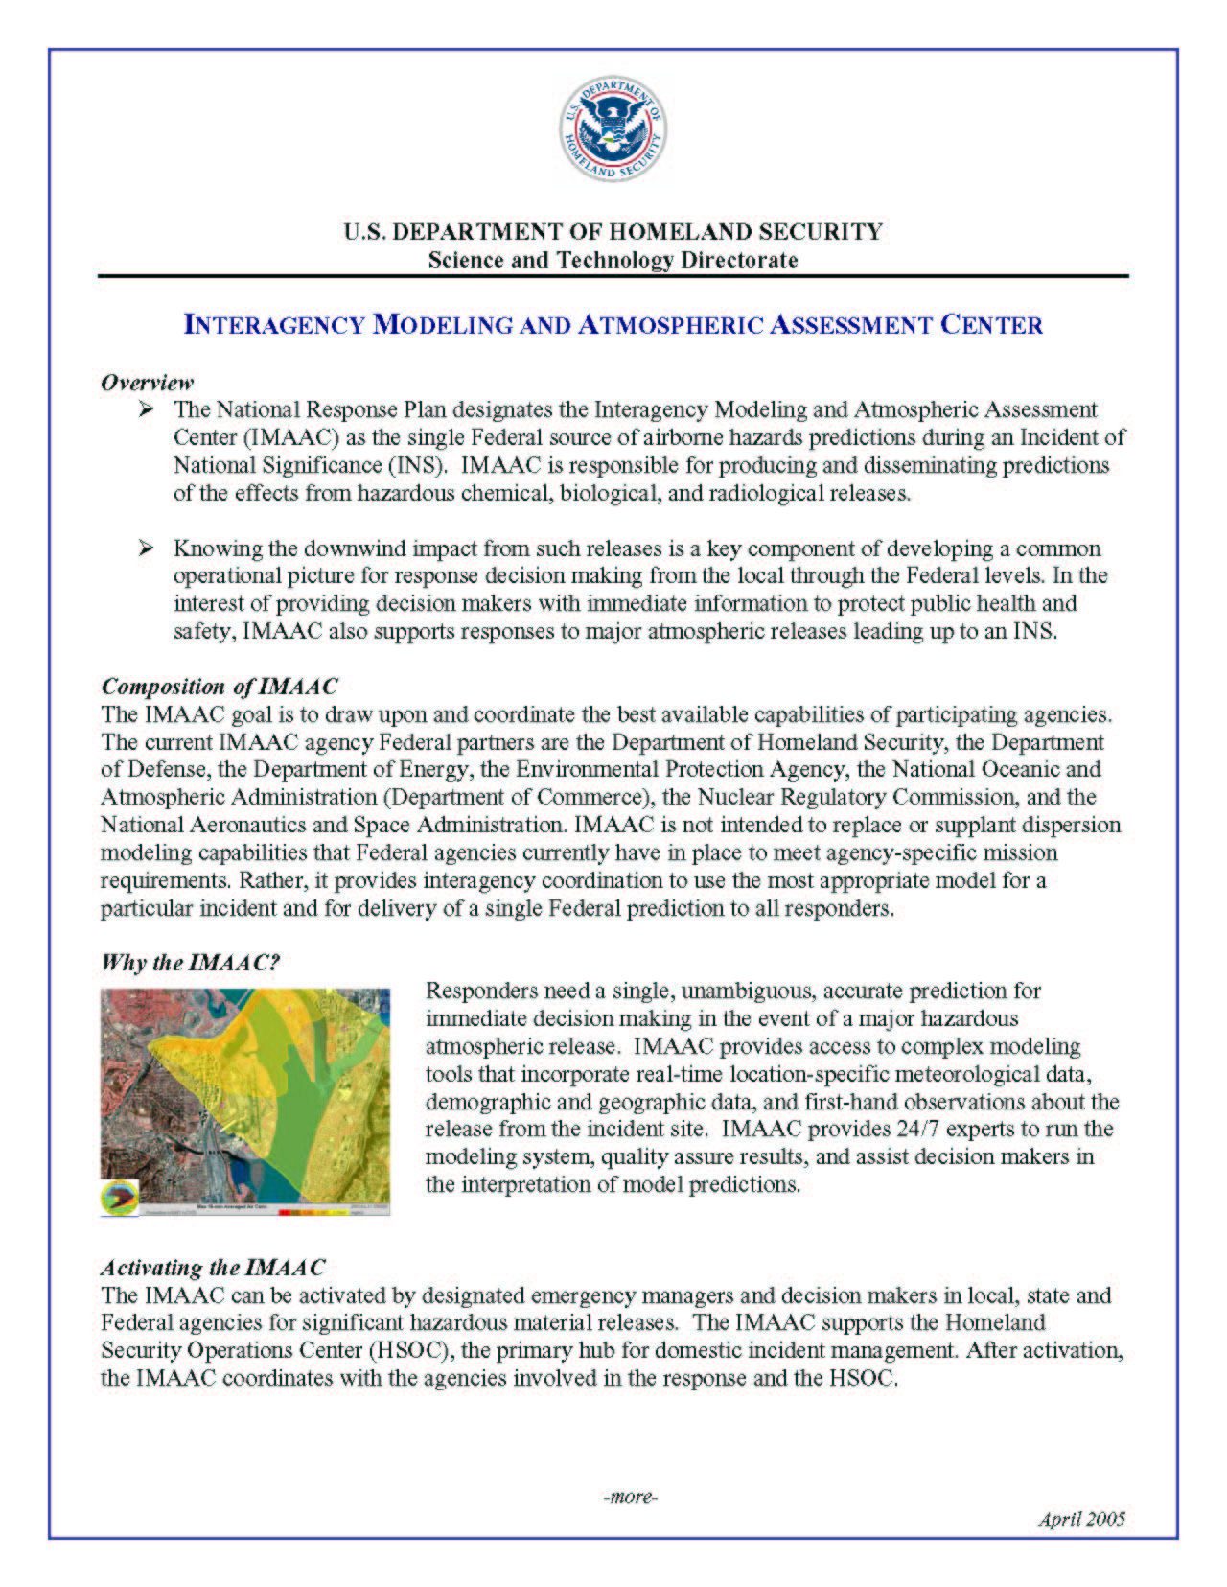

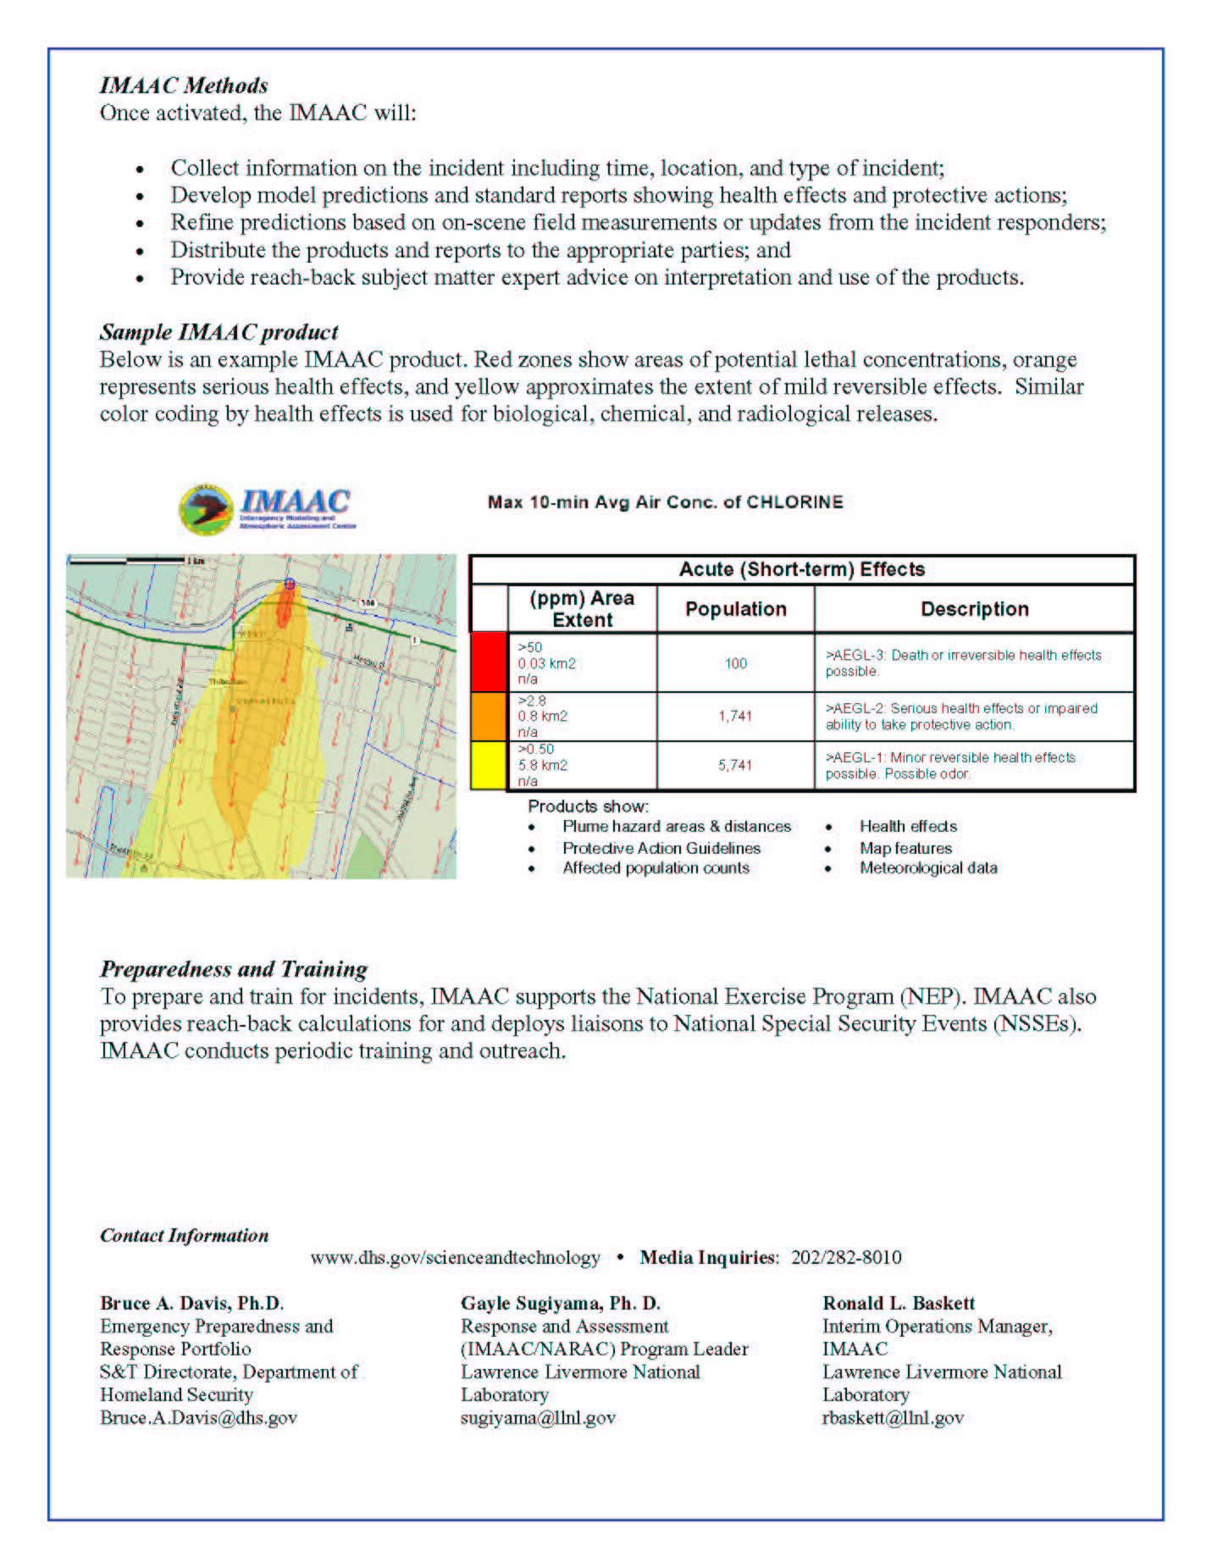
APPENDIX X: Special Teams Compendium

COMPENDIUM OF SPECIAL TEAMS, CAPABILITIES AND ASSETS
July 17, 2006

I. INTRODUCTION

This is an informational guide for federal, state, tribal and local responders and planners located in EPA Region IX. This Region encompasses California, Arizona, Nevada, Hawaii, Pacific Island Trust Territories (i.e., American Samoa, Guam) and Commonwealth Islands (i.e., Northern Marianas). It provides a reference source for emergency responders and planners on the capabilities of various Federal special teams and assets that may be called upon to support federal, state, tribal and local response to major incidents involving oil spills, hazardous material incidents, natural disasters, Weapons of Mass Destruction (WMD) and other emergencies and disasters. The compendium used existing information on 21 special teams described in the Hazardous Materials Response Special Teams, Capabilities and Contact Handbook 2002 (updated in 2005) published by the United States Coast Guard (http://www.uscg.mil/hq/g-m/2005SpecialTeamsHandbook.pdf). The compendium expanded and updated the existing information and included an additional 63 special teams and assets. In addition to the 84 special teams and assets, an additional 55 Federal teams and assets were listed, but not described, in this compendium. These Federal Teams’ missions are briefly described in Appendix 2 – Inventory of Federal Response Teams, Catastrophic Incident Supplement (2006), National Response Plan and the DHS/EPR/FEMA Emergency Teams Handbook. An addendum at the back of the document provides emergency and non-emergency contact information for each agency team and asset. These agency contacts assisted in editing and updating the information in the compendium.

This guide provides valuable information to emergency responders from all jurisdictions including federal, state, tribal and local agencies and non-governmental organizations. This information should be useful to response personnel that participate in multi-agency/multi-jurisdictional response, incident command system/unified command, national, regional and local area contingency planning, training exercises, national security special events (NSSE) and other emergency preparedness and response activities. It is another tool that can be used by agency personnel to become familiar with other agency’s capabilities and assets and gain a better understanding of what they can bring to the response. The compendium will be placed in the Region IX Mainland and Oceania Regional Contingency Plans.

The National Oil and Hazardous Substances Pollution Contingency Plan (NCP) describes the National Response System (NRS) and Special Forces that are an integral part of the NRS. These Special Forces are available to support a Federal On-Scene Coordinator (FOSC) during environmental emergencies. The U.S. EPA and U.S. Coast Guard have pre-designated FOSCs for emergency response to oil discharges and hazardous substance releases in the inland and marine zones, respectively. Two other Federal agencies, DOE and DOD, have FOSCs for emergency response to releases of hazardous substances that occur on their facilities or vessels in accordance with the NCP. The special teams listed in the compendium include those mandated as Special Forces under the NCP as well as other significant Federal agency teams and assets. Some of these may be useful resources to the FOSC, the Incident Commander, a Unified Command, an Area Command, an Emergency Operations Center (EOC) or a Joint Field Office (JFO). A team listed below with an asterisk is a member of the Special Forces under the NCP.

Using off-site coordination and support mechanisms of the NRS, the FOSC should be able to access many of the teams or assets through the Regional Response Team (RRT) and its member agencies. The RRT membership is comprised of 16 Federal agencies including EPA, DHS (USCG, FEMA), DOD, DOE, DOJ and HHS. The Federal agency member on the RRT (or NRT) such as the DOE representative should be able to contact the appropriate Department official who can authorize deployment of a special team or asset For example, the DOE/RRT representative may contact the Lawrence Livermore National Laboratory (LLNL) to request response assistance from DOE/NARAC/IMAAC to model an airborne release. In this case, the IMMAC Coordinator at LLNL would work directly with the FOSC to develop a scope of work, plan the logistics and execute an interagency agreement for cost reimbursement…

Refer to ENVL Job Aid Reference CD for complete document

